**Title:** CS1026 Lab 4

**Date:** 17/02/2017

**Aim:** To design a circuit to implement F(A,B,C,D) = ∑m (0,2,5,6,9,11) using the Quine-McCluskey Method.

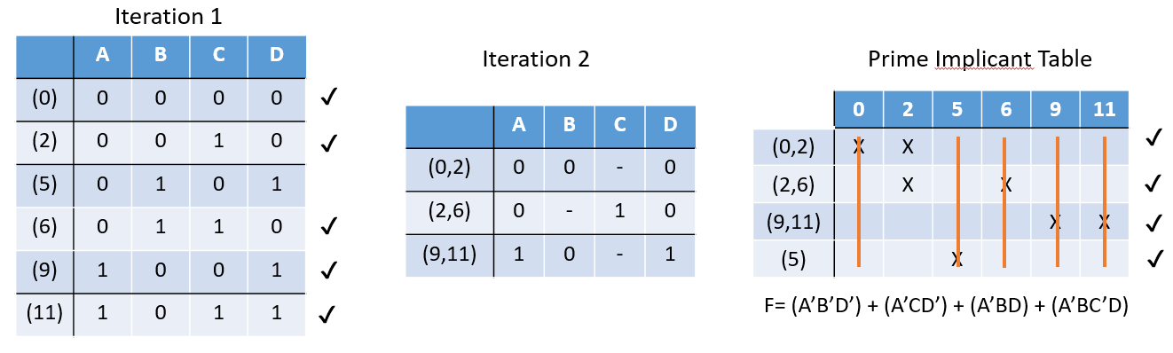

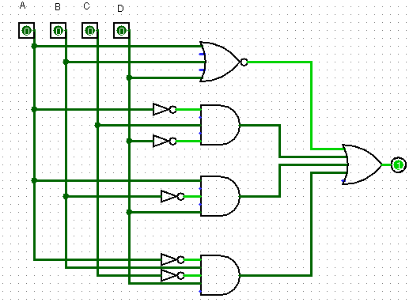

**Analysis:**

* I began by designing the first table made up of the grouped minterms
* Following this I then grouped the minterms with minterms from the group below it producing the second table
* When no more minterms could be grouped I then made a prime implicant table using the prime implicants (terms that were not selected)
* Using column and row dominance methods I then reduced the table to the minimum SOP solution as seen above.
* Following this I then built and tested a circuit to implement this solution using Logisim.

**Boolean Algebra:**

**F= (A’B’D’) + (A’CD’) + (A’BD) + (A’BC’D)**